Understanding osteogenesis in health, development and disease

INFORMATION SHEET MINORS AGE 10-15

Collection of tissues and blood from spine surgery

We are asking whether you would be interested in taking part in a RESEARCH study.

Before you decide if you would like to join in, it is important for you to understand why the research is being done and what it will involve.

Please take the time to read the following information carefully and discuss it you’re your parent or guardian, friends and relatives if you wish. Please ask us if there is anything that you do not understand, or if you have any questions.

Feel free to give us a call and we can talk about it with you and your parents or guardian.

Thank you for reading.

1. Why are we doing this research?

We want to understand how the bones of the spine grow and repair themselves and why this process sometimes goes wrong. Your spine in made up of lots of different types of cell, stem cells are a special type of cell that can turn into bone, fat or cartilage.

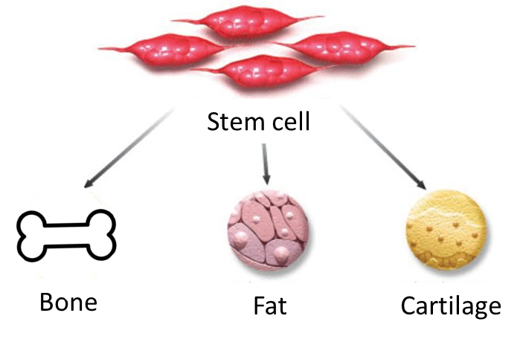
Sometimes these cells don’t work properly and this means that they either make too little or too much bone but we don’t understand why this happens. This research will be trying to understand what makes the stem cells make bone.

2. Why have I been chosen?
You have been chosen for this study because you will be having an operation on part of your back. As part of the operation, a small piece of bone and connective tissue may be removed. This is called the spinous process and the interspinous ligament, these would usually be thrown away, but we would like to keep them, and use them in our research.

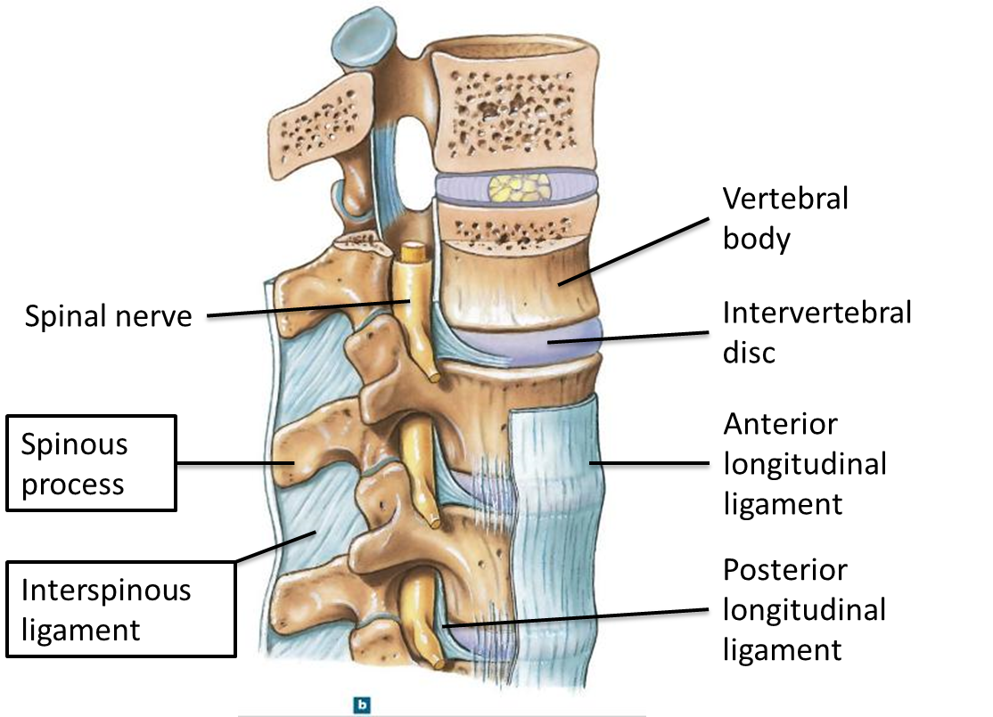

We would also like your permission to take a small amount of bone marrow and blood. Bone marrow is the liquid that is inside your bones.

3. Do I have to take part?
No. It is up to you to decide whether or not to take part, nobody will be angry or upset if you don’t want to. If you say yes but then you change your mind that’s ok, again nobody will mind.

4. If I decide to take part but then change my mind who should I tell?

Just let any of the doctors or nurses that are looking after you know. You can also tell your parent or guardian or get in contact with Professor McGonagle whose contact details are on the bottom of this sheet. You don’t have to give any reason it’s your choice.

5. What will happen to me if I take part?
If you decide to take part you will be asked to sign an informed assent form, and you will be given a copy of this information sheet to keep. Your operation will proceed as normal. You may also be asked to give a small blood sample.

6. What do I have to do?
You don’t have to do anything apart from have your operation as planned and give a blood sample.

7. What are the side effects of taking part?
There are no side effects from donating tissue, but some people do get mild side effects when donating blood, these could include Bruising, a sore arm, dizziness and fainting.

8. What are the possible benefits of taking part?
You will not benefit directly from taking part in this research. You will not be treated any differently whether or not you decide to take part.

9. What if something goes wrong?
Don’t worry, the doctors and nurses will be keeping a very close eye on you. But if you have any problem about the research you should talk to your parents, your doctors or nurses or contact Professor McGonagle.

10. Will my taking part in this study be kept private? Will anyone else know that I am taking part?
As soon as tissue sample is taken from you, all information that identifies you will be removed so that you cannot be recognised. The only identifying information held by the University of Leeds will be that on the consent form that you will sign if you choose to take part, this will be stored securely so that only members of the research team will have access.

11. What will happen to the samples I give?
The samples that you give will be stored in a safe place we will use the samples to do experiments in the laboratory to understand how stem cells work. We might keep the samples in case we need to do more experiments in the future.

12. What will happen to the results of the study?
At the end of the study, the results will be written up so that people all over the world can read about it, but they won’t know that you were in the study.

13. Who is organising the research?
This project is being organized by Doctors of Leeds St. James Hospital and Leeds General Infirmary under the supervision and support of the University of Leeds.

14. Who has reviewed this study?
This study has been reviewed by the independent ethics committee called the North West - Greater Manchester West Research Ethics Committee. This committee is there to decide that the study is fair. We have received approval by this committee to be able to do this research study.

15. Contact for further information
For further information on the study please contact:

Professor D. McGonagle,
Telephone 0113 3924747
E.mail: D.G. McGonagle@leeds.ac.uk

